Project Report On

Alexa Voice Command to Control Devices

Submitted To Hed-x In IOT(Internet of things)

By

**PAVAN KUMAR H M**

**KUSHAAL H N**

**GIRIDHAR R**

**SANTHOSH K**

Under the guidence of

[**Surendra Parihar**](http://projects.hed-x.com/wp/members/surendra-parihar/)

**ABSTRACT**

This project is aimed at developing a system capable of controlling any device by using voice command and making use of concept called Internet of Things (i0t).

The Internet of Things is a system of interrelated computing devices, mechanical and digital machines, objects, animals or people that are provided with unique identifiers and the ability to transfer data over a network without requiring human-to-human or human-to-computer interaction.

This project is a combination of Voice Technology, Cloud Networking and Embedded system. The device must be connected to particle photon and which is configured with wifi. By IFTTT recipe using ALEXA and particle cloud to control the device.

**REQUIREMENT SPECIFICATION**

1**.** Hardware:

* 1. Android mobile / Tablet PC
  2. Particle Photon
  3. LED
  4. Bread board

2. Software:

* 1. IFTTT Website Registration
  2. Particle cloud Registration
  3. AWS(ALEXA) Registration
  4. Echosim.io
* This project is a combination of Voice Technology, Cloud Networking and Embedded system.
* Here One has to configure AWS account. On the other hand connect a device with particle photon and configure it with wifi.
* Then  write a code to control device on particle cloud.
* Then on IFTTT Website creates a recipe using ALEXA and particle cloud to control the device.
* Now by using echosim.io one can a send a voice command  which is already registered to control the device.

**SYSTEM DESCRIPTION**

The system consists of the Particle Photon board as its core. The device to be controlled(LED) is physically connected onto the board through either the digital or analog pins on the board.

The system is controlled using the IFTTT “Do-button” app, thereby allowing the user to control the appliance wireless over the internet.

To achieve this, first a function is declared in the particle cloud space. This function is then designed and developed to control the appliance connected with the board. Once that is done, the function is merely called using the Do-button app with the appropriate parameters.

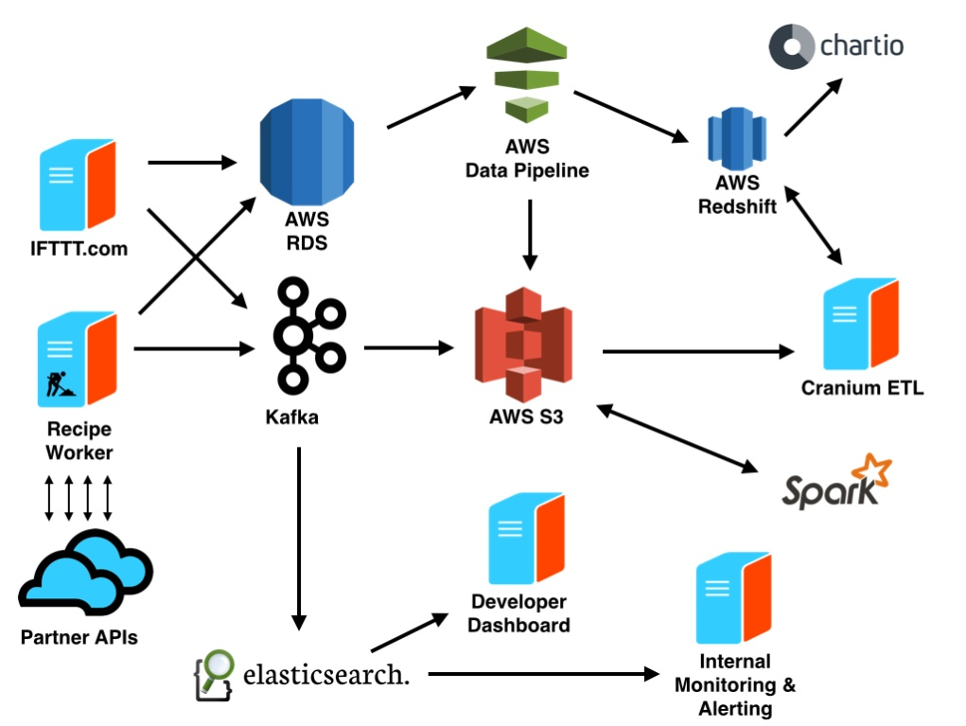

***Architecture of IFTTT***

**BLOCK DIAGRAM**

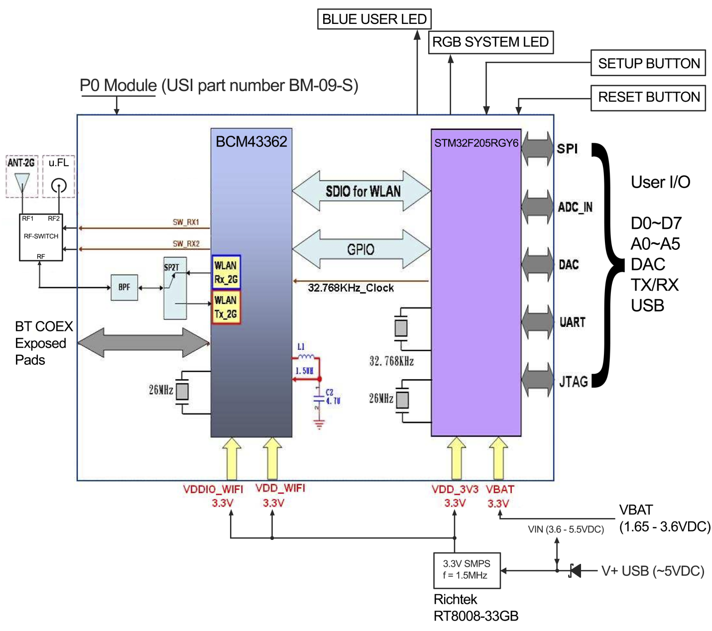

**CIRCUIT DIAGRAM**

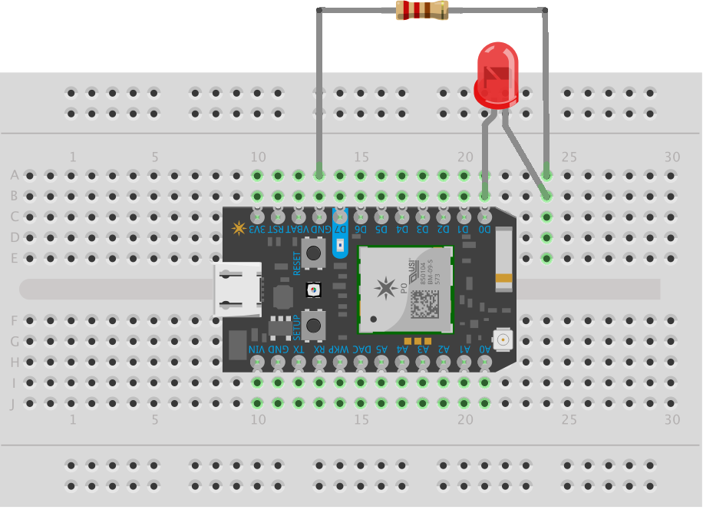

**SOURCE CODE**

/* Function prototypes -------------------------------------------------------*/

int tinkerDigitalRead(String pin);

int tinkerDigitalWrite(String command);

int tinkerAnalogRead(String pin);

int tinkerAnalogWrite(String command);

/* This function is called once at start up ----------------------------------*/

void setup()

{

//Setup the Tinker application here

//Register all the Tinker functions

Spark.function("digitalread", tinkerDigitalRead);

Spark.function("digitalwrite", tinkerDigitalWrite);

Spark.function("analogread", tinkerAnalogRead);

Spark.function("analogwrite", tinkerAnalogWrite);

}

/* This function loops forever --------------------------------------------*/

void loop()

{

//This will run in a loop

}

int tinkerDigitalRead(String pin)

{

//convert ascii to integer

int pinNumber = pin.charAt(1) - '0';

//Sanity check to see if the pin numbers are within limits

if (pinNumber< 0 || pinNumber >7) return -1;

if(pin.startsWith("D"))

{

pinMode(pinNumber, INPUT_PULLDOWN);

return digitalRead(pinNumber);

}

else if (pin.startsWith("A"))

{

pinMode(pinNumber+10, INPUT_PULLDOWN);

return digitalRead(pinNumber+10);

}

return -2;

}

int tinkerDigitalWrite(String command)

{

bool value = 0;

//convert ascii to integer

int pinNumber = command.charAt(1) - '0';

//Sanity check to see if the pin numbers are within limits

if (pinNumber< 0 || pinNumber >7) return -1;

if(command.substring(3,7) == "HIGH") value = 1;

else if(command.substring(3,6) == "LOW") value = 0;

else return -2;

if(command.startsWith("D"))

{

pinMode(pinNumber, OUTPUT);

digitalWrite(pinNumber, value);

return 1;

}

else if(command.startsWith("A"))

{

pinMode(pinNumber+10, OUTPUT);

digitalWrite(pinNumber+10, value);

return 1;

}

else return -3;

}

int tinkerAnalogRead(String pin)

{

//convert ascii to integer

int pinNumber = pin.charAt(1) - '0';

//Sanity check to see if the pin numbers are within limits

if (pinNumber< 0 || pinNumber >7) return -1;

if(pin.startsWith("D"))

{

return -3;

}

else if (pin.startsWith("A"))

{

return analogRead(pinNumber+10);

}

return -2;

}

int tinkerAnalogWrite(String command)

{

//convert ascii to integer

int pinNumber = command.charAt(1) - '0';

//Sanity check to see if the pin numbers are within limits

if (pinNumber< 0 || pinNumber >7) return -1;

String value = command.substring(3);

if(command.startsWith("D"))

{

pinMode(pinNumber, OUTPUT);

analogWrite(pinNumber, value.toInt());

return 1;

}

else if(command.startsWith("A"))

{

pinMode(pinNumber+10, OUTPUT);

analogWrite(pinNumber+10, value.toInt());

return 1;

}

else return -2;

}

**CONCLUSIONS AND CHALLENGES**

With all the accumulated effort, the project successfully showed desired results corresponding to the problem statement. This project can be modified to facilitate the working of real world objects such as home appliances using voice command.

Some of the main challenges faces through the course of the project were

1. Understanding the working of the “particle” app and integrating it with the function written over the cloud.
2. Coding the function that switches the led on/off as per the need

*******